Stormwater Management System: TCNJ Townhouses South

Team Members: Kelly Hommen, Elizabeth Lafferty (PM), Michael Murphy, Charles Stewart Advisors: Dr. Michael Horst and Dr. Vedrana Krstic
  - TCNJ Senior Project I December 2012

Stormwater Management System: TCNJ Townhouses South

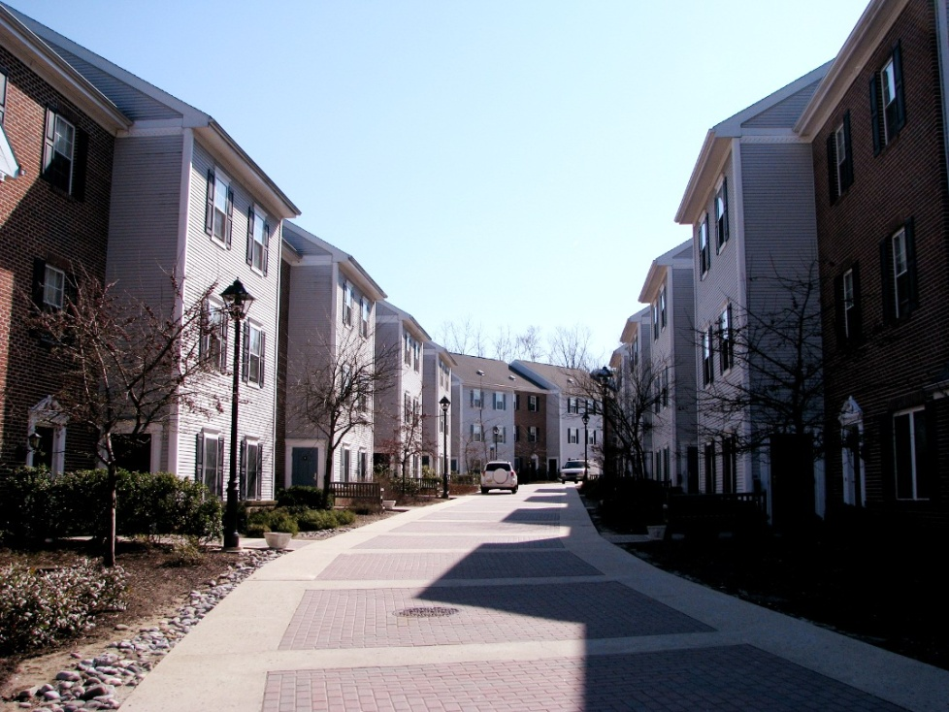

An Analysis Project for Senior Project I
Submitted to the Faculty of the Civil Engineering Department
of The College of New Jersey

Written and Researched by:
Kelly Hommen
Elizabeth Lafferty
Michael Murphy
Charles Stewart

In partial fulfillment of the Bachelor of Science degree in Civil Engineering

December 2012
Abstract:
The College of New Jersey’s Townhouses South residences experience water infiltration and persistent dampness in their crawlspaces. Townhouses South is comprised of 26 individual units each of which has a crawlspace extending approximately 3 feet below the surface. Of the 26 units, standing water was detected in the crawlspaces of 15 of them, and all but 6 have noticeable moisture. This study is intended to determine the foremost cause of the water infiltration and propose a solution to maintain the structural integrity of the Townhouses. Through the use of geotechnical, hydrologic, and hydraulic analysis, data was collected to allow for proper analysis and the proposal of adequate solutions. Geotechnical testing was conducted in accordance with ASTM standards, and soil was classified using Burmister classification system to produce a soil profile. The profile is comprised of four stratums; the top three consist of brown sand with trace amounts of silt. The final stratum, located seven feet below the surface, is brown sand with clayley silt. The hydraulic conductivity of the first five feet of the soil profile was determined to be 0.001323 ft/min. A ground water well was installed in close proximity to the most critical crawlspaces and extended to a depth of seven feet below the surface. Although no groundwater table was found, continuous monitoring will occur. With the use of topographic maps, watershed properties were obtained and used in combination with rainfall estimates to predict the volume of infiltrated water for a 2 year, 24 hour storm event. The watershed was divided into two separate areas, impervious and pervious. The areas were found to be 0.98 acres and 0.94 acres, respectively. The computer modeling software HEC-HMS was utilized and returned total absorbed water of 0.12 inches and 2.47 inches for the respective areas. During Senior Project II, designs to remediate this problem will be considered for future use. Potential solutions include an underground storm water collection and recycling system, regrading of the soil surrounding the townhouses, a rooftop rainwater catchment system, and a design for sump pumps in the crawlspaces.

Table of Contents
Fulfillment Page i
Abstract ii
Table of Contents iii
Table of Figures iv
Table of Tables v
Chapter 1: Introduction 1
Chapter 2: Team Management (Elizabeth Lafferty) 2
Chapter 3: Background (Elizabeth Lafferty)
3.1 Overview 3
3.2 Best Management Practice Research 3
3.3 Site Description 3
3.4 Conclusion 4
Chapter 4: Soil Analysis (Kelly Hommen)
4.1 Overview 5
4.2 Soil Sampling 6
4.3 Field Testing 7
4.4 Groundwater Table Monitoring Well 7
4.5 Laboratory Testing 9
4.6 Soil Classification 13
4.7 Hydraulic Conductivity of Soil 13
4.8 Conclusion 13
Chapter 5: Hydraulic and Hydrologic Analysis (Michael Murphy and Charles Stewart)
5.1 Overview 15
5.2 Watershed Delineation 15
5.3 Modeling Site Conditions 17
5.4 Calculating Lag Time 18
5.4.1 SCS Regression Method
5.5 Conclusion 19
Chapter 6: Computer Modeling (Michael Murphy and Charles Stewart)……………………………………20
Chapter 7: Future Designs (Elizabeth Lafferty) 23
Chapter 8: Conclusion (Elizabeth Lafferty) 24
References 25
Appendix A: Project Overview 26
Team Members
Engineering Standards and Realistic Constraints Form SPI
Realistic Constraints and Engineering Standards Presentation
Safety Essay

Appendix B: Team Management 32
Gantt Chart
Weekly Meeting Minutes Example
Contact List

Appendix C: Site Description 36
Aerial Photo

Appendix D: Soil Analysis 38
Natural Moisture Content Results
Sieve Analysis Results
Laboratory/Field Testing Equations
Typical Values for Hydraulic Conductivity
NJBMP Procedures
Burmister Classification
Lab Data Sheet Example

Appendix E: Hydrologic Analysis 48
Table of Runoff Curve Numbers
NOAA Website Table of Total Rainfall

Stormwater Management System: TCNJ Townhouses South
List of Figures
Figure 2.1.1: Townhouse South Stormwater Management Website…………………………………………………….2
Figure 3.3.1: Site Location………………………………………………………………………………………………………………….3
Figure 3.3.2: Watersheds………………………………………………………………………………………………………………….4
Figure 4.1.1: Location of Soil Borings, Percolation Tests, and Groundwater Table Monitoring Well….. 5
Figure 4.3.1: Percolation Test……………………………………………………………………………………………………………..7
Figure 4.4.1: Groundwater Monitoring Well (Profile View)……………………………………………………………….8
Figure 4.4.2: Groundwater Monitoring Well………………………………………………………………………………………8
Figure 4.5.1: Grain Size Distribution Curves……………………………………………………………………………………..11
Figure 4.6.1: Soil Profile………………………………………………………………………………………………………………………
Figure 5.2.1: Watershed ………………………………………………………………………………………………………………………16
Figure 5.2.2: Longest Hydraulic Length………………………………………………………………………………………………17
Figure 5.3.1: Soil Type………………………………………………………………………………………………………………………18
Figure 5.3.2: Soil Breakdown…………………………………………………………………………………………………………………18
Figure 6.1: HEC-HMS………………………………………………………………………………………………………………………21
Figure 6.2: HEC-HMS………………………………………………………………………………………………………………………21
Figure 6.3: HEC-HMS………………………………………………………………………………………………………………………22
Stormwater Management System: TCNJ Townhouses South
List of Tables

Table 4.5.1: Natural Moisture Content Results…………………………………………………………………………….9
Table 4.5.2: Results for Atterberg Limits………………………………………………………………………………………
Table 4.7.1: Relationship of Field Calculations to Empirical Values………………………………………………13
Table 6.1: Land Use and Design Storm Return Period …………………………………………………………………20

